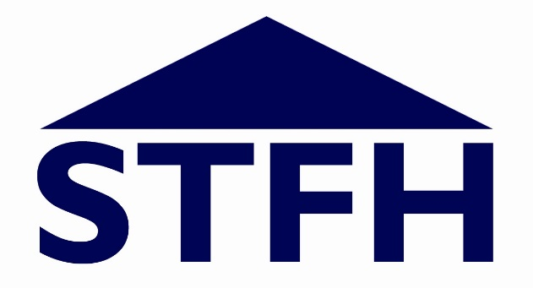

SALISBURY TRUST FOR THE HOMELESS

ANNUAL STATEMENT OF BOARD APPOINTMENTS & COMPOSITION

FOR THE REPORTING YEAR 2021-22
March 2022

ROLE OF THE BOARD

The purpose of the Board is to direct the affairs of the charity in accordance with its objects and constitution and ensure that its functions are properly performed. These functions are set out separately in its Terms of Reference.

CONSTITUTIONAL REQUIREMENTS
The Board of STFH is unpaid and currently consists of 7 non-executive members (the maximum permitted size of the Board is 12 people).
Tenure
All members serve terms of 3 years at a time up to a maximum of 2 terms (6 years) as a general expectation under the Code of Governance that the charity, via its Parent organisation, BCHA, has adopted (National Housing Federation, 2020). Subject to established business need, members may serve a 3rd term (up to a maximum of 9 years’ overall service) although appointment for a third term will be subject to approval by the Board.
Of the current members:
- 3 are serving their first term,
- 4 are serving a second term and
- 0 is serving in their third term
- The average length of service for the whole board is 3.7 years.
No Board members have announced they will be stepping down in 2022.
Parent Nominee Board Members
The Parent Organisation, BCHA, is able to nominate trustees for the Board such nominees being board members of BCHA, board members of other subsidiary organisations or senior managers at BCHA (albeit trustee status is unpaid). There is currently one Parent nominee sitting as a trustee on the STFH Board – Rachel McMillan.
Resident Board Members
Whilst there is no constitutional requirement for resident board members, we do encourage candidates with lived experience of our services or of homelessness or those with residency or former residency in our accommodation or social housing more widely to apply to join the Board.
There are currently no board members who are STFH residents or who have disclosed lived experience.
Ex-Oficio Members
To strengthen its partnership working, STFH has granted a serving Wiltshire Council member the right to attend our board as an observer.
Co-optees
There are no co-opted members on the Board.

APPOINTMENTS IN 2021-22
There were no resignations in the reporting year other than the BCHA nominated trustee who was replaced by a further nomination from BCHA – Rachel McMillan, the Financial Controller at BCHA.

BOARD SKILLS & EXPERIENCE
Subject to vacancy, Board membership is open to any person aged 18 or older who possesses the time and skills required by the Organisation to perform the role.
The Board seeks to recruit people with specific skills and experience which are appropriate to our business - its size, activities, risks and opportunities.
Skills
General Skills and Experience which the Organisation seeks for the Board:
Skill/Experience | No Serving Board members with this skill/experience
Working locally with housing, homeless or social care sectors | 2
Welfare Benefits | None but rely on officer, BCHA and external guidance
Financial management | 2
Charity/Voluntary sector (including fundraising) | 4
Business management and/or business development | 4
PR & media skills | 1

NB: one board member may have skills in more than one of the above areas so the number in the right hand column may exceed the number of individuals on the Board. This list of desirable skills may be amended from time to time to reflect ongoing business needs.
In addition, all board members must have the ability to exercise good judgement and to be confident to participate in board meetings and be able to constructively challenge, as necessary.
A pen portrait of each Board member can be viewed on our website.

BOARD DIVERSITY
STFH collects information provided by Board members to ensure that the make-up of the Board is diverse and seeks to reflect the communities where we work. Bearing in mind that one board member comprises 14% of the Board, we do expect fluctuation upwards and downwards against each diversity strand every year as people join and leave the Board.

Diversity Strand | STFH Board | Population Average  SW
Race/Ethnic Origin – % Black, Asian & Minority Ethnic heritage | 0% | 4.5%  ONS ABES 2016
Age - % under/over age 55 | 28% under 55  72% 55+  [28% of board working age] | 18-54 = 44.4%  55-80 = 29.3%  ONS 2020 Wilts only
Gender – Male & Female | 57% M; 43% F | 49% M & 51% F  ONS 2020
Sexuality - % LGB | Not currently collected | 2.7%  ONS 2019 (popn. 16+)
Disability – % declared | 0% | 18% for UK  although varies by age  ONS 2020

NB: percentages are based on declarations by board members. We have not compared the board’s diversity profile with the staff team as the latter only comprises three people.
Work is ongoing through our Equality, Diversity & Inclusion Strategy to ensure a diverse board is maintained as part of ongoing succession planning and recruitment.

BOARD SUCCESSION
No members have indicated their intention to step down from the Board at the time of publication. However, where there are unplanned departures due to personal commitments, for example, vacancies will be subject to our standard recruitment process.

